1. Create a Project Plan. (Workout Tracker, Assignment Tracker, etc.). Explain your whole idea (along with words, better come up with some visuals, keep in mind, a picture is worth a thousand words)

For my project, I decided to create an upcoming university assessments tracker. This tracker will be a very useful tool to help me keep track of all upcoming assessments that I have from all my current semester courses. Whether it's an upcoming test, quiz, assignment, midterm or final, this tracker will be able to organize them into a neat table, which I can refer to to know which assessments to prepare to complete/study for. This would especially be helpful as we are nearing the end of the semester, when students are now facing a tight schedule to complete assignments and study for finals. The layout of my website with this design will be simple. I will maintain my current portfolio design with about me, contact me and projects, but will now have an additional dashboard page to view the table for upcoming assessments. On this page, I will have buttons to edit/delete an object beside the corresponding assessment, and have a button to add a new assessment at the end of the page. As I already have experience with CRUD from the final project part 1, I will try to maintain the same format as that, since it was visually appealing, and will fit my plan of an assessment tracker.
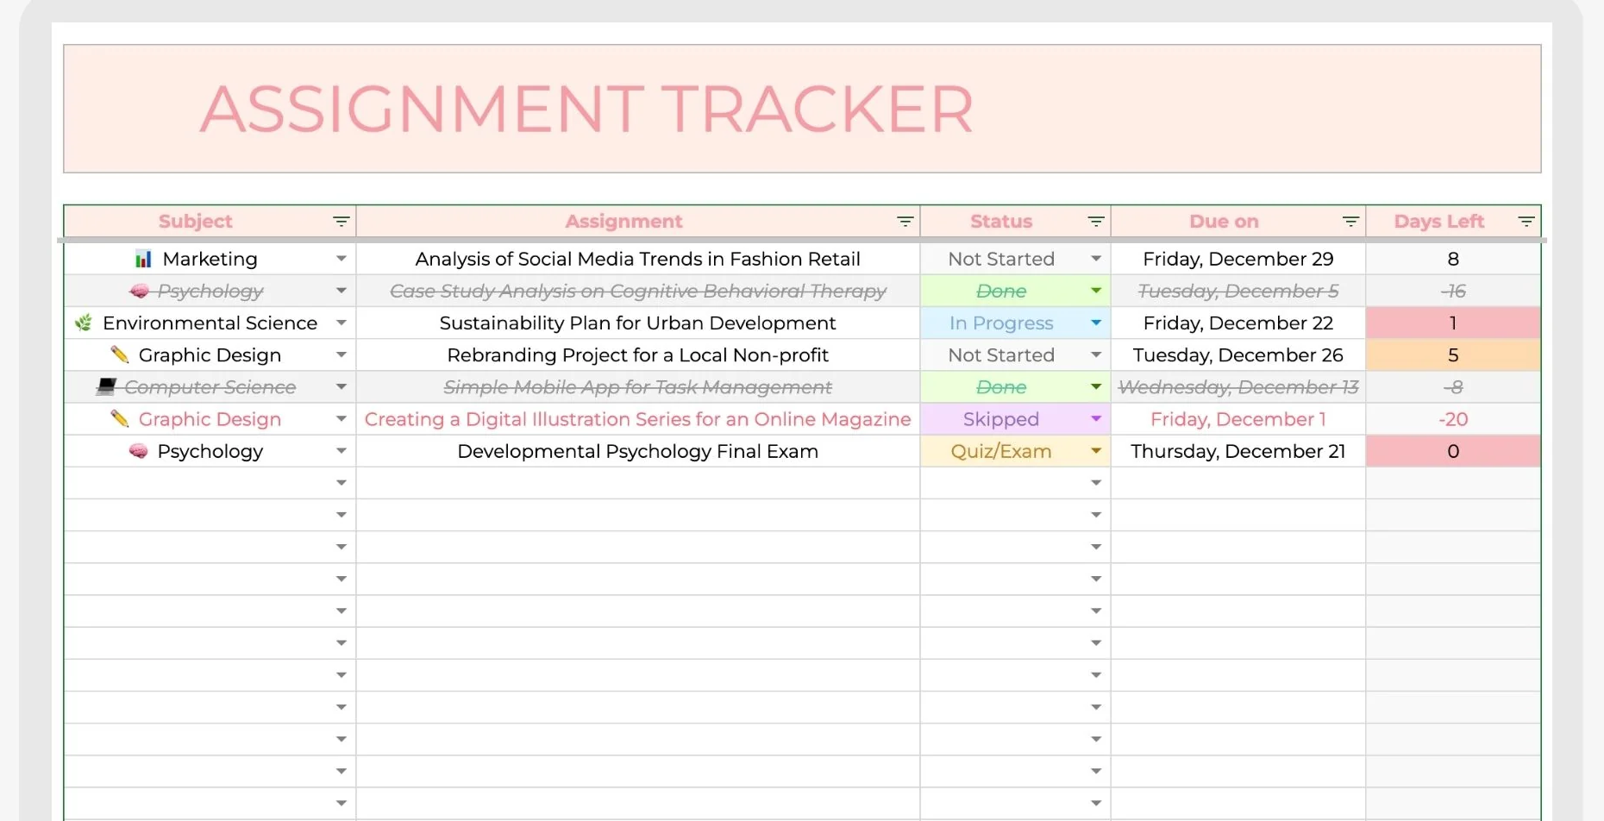
Above is an image of an example assignment tracker online, which contains columns for the due date, status, assessment name and the course, type (quiz, test, assignment, etc), all of which I also plan to include for my assessment tracking table.

